Automatic Focusing Video Microscope SI-VMA: An automatic focusing video microscope capable of storing images and videos on a USB drive.

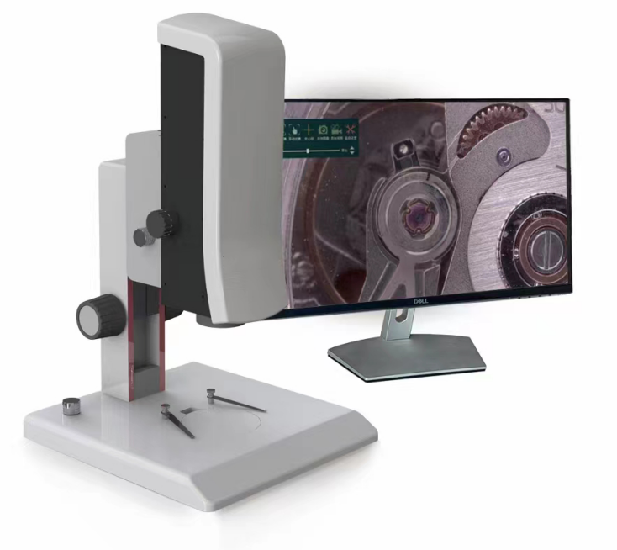

Plug and Use: No complex installation steps required. Our independently developed exclusive technology allows the system to support objective lens replacement, adapting to various working environments. The real-time focusing feature doubles work efficiency. With magnification up to a thousand times, you can clearly observe object details, ensuring more precise quality control.
Product Application


电子行业
Electronic
手机行业
Phone
五金行业
Hardware
钟表行业
Clocks
机械行业
Mechanical
汽车行业
Car
Automatic Focusing Video Microscope
Cases

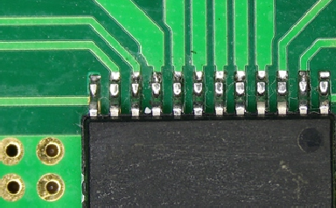 | 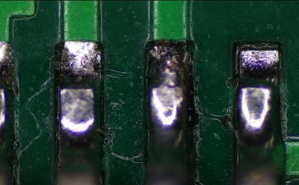 | 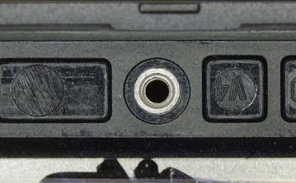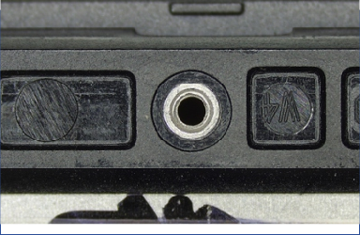
Application Examples in the Electronics Industry | Application Examples in the Electronics Industry | Application Examples in the Mobile Phone Industry
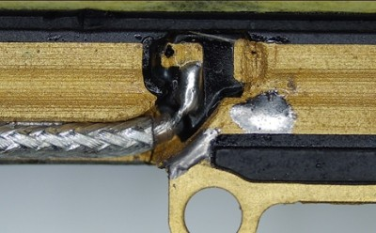 | 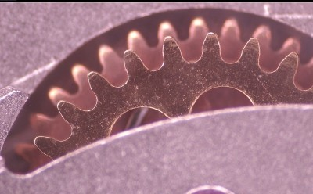 | 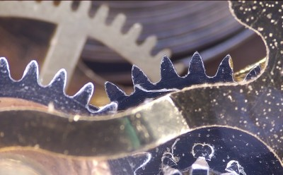
Application Examples in the Mobile Phone Industry | Application Examples in the Watchmaking Industry | Application Examples in the Watchmaking Industry

Automatic Focusing Video Microscope
Advantages

Helps You Speed Up Your Workflow! |  | Helps You Discover More Details! |  | Helps You Find More Convenience!
No eyepiece required, large display screen is more conducive to observation; real-time focusing eliminates the need for manual focusing, saving time; continuous zoom allows for quick magnification changes. |  | Unique HDR function with edge enhancement mode for clearer images; electronic magnification up to 180X for detailed reproduction;  2-megapixel HD camera captures images at 60 frames per second. |  | Insert a USB drive to store photos and dynamic videos; Simple human-machine interface makes operation intuitive; Provide multiple light source matching modes according to customer sample characteristics.
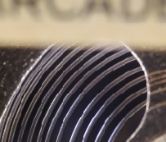 | 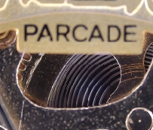 | 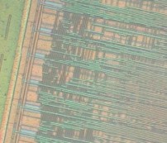 | 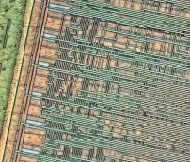 | 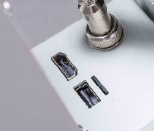   |   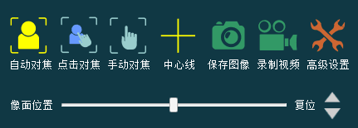
Move the observed position to the focusing frame to observe clear focused images. |  | Normal Observation (Integrated Circuit 180X) | HDR Observation (Integrated Circuit 180X) | USB drive can store images and dynamic videos | User-friendly and intuitive human-machine interface

Automatic Focusing Video Microscope

Parameters
Product | SI-VMA
Specifications | Dimensions | 320 × 308.5 × 417.5mm
Specifications | Detected Object Size | Maxi Height Limit 50mm
Optical Parameters | System Magnification | 32.9-211.6X
Optical Parameters | Field of View Size | Max：14.462*8.135mm；Min：2.249*1.265mm
Optical Parameters | Resolution | ≤3μm
Optical Parameters | Working Distance | 95mm
Camera Parameters | Image Sensor | COMS
Camera Parameters | Effective Pixels | 200W
Camera Parameters | Sensor Size | 1/2.8"
Camera Parameters | Connection Method | HDMI
Camera Parameters | Exposure Mode | Automatic / Manual
Camera Parameters | Scanning Method | Support for Line-by-Line Scanning
Camera Parameters | Operating Temperature | 0℃-50℃
Camera Parameters | Digital Zoom | Support
Camera Parameters | Storage Function | Support for USB Storage
Instrument Configuration | Light Source | Ring Surface Light
Instrument Configuration | Lenses | 0.7x - 4.5x（manual）
Instrument Configuration | Output and Operation Modes | USB & HDMI Display Cable

